
Confirmit Open Dialer API.
Call Transfers Support.
v.1.1

Contents

Contents 2
Introduction 3
Configuration of call transfers 3
Scanario 1 (cold transfer) 3
Scanario 2 (basic warm) 3
Scanario 3 (no answer) 3
Scenario 4 (switching back to respondent) 4
Scenario 5 (3-way conference mode) 4
Call Transfer Sequence Diagrams 4
Cases. 4
Case 1. External Cold. 5
Case 2. External Warm. 6
Case 3. Internal Cold Predictive 7
Case 4. Internal Cold Non-Predictive 8
Case 5. Internal Warm Predictive. 9
Case 6. Internal Warm Non-Predictive 10
Open Dialer Call Transfers Support API 11
TransterStart 11
TransferSetTarget 11
TransferSetConnectionState 11
TransferComplete 11
TransferCancel 12
NotifyTransterState 12

Introduction

Call transfer functionality will allow running projects where maximization of response rate is a major priority which makes the call transfer capability a mandatory requirement. .
Basic call transfer scenarios include “cold” and “warm” call transfers. The “Cold” call transfer can be considered as an individual case of a more general “warm” call transfer.

Configuration of call transfers

There are 2 possible ways to initiate a call transfer – the first is via a telephony node in a survey (automatic transfer), the second is via the button in the CATI Console toolbar (manual transfer).
The Automatic call transfer is initiated via telephony node in a survey and it supposes specifying all the required information:
- transfer type (cold/warm) and
- either telephone number (for an external call transfer) or an interviewer or a group name (for an internal call transfer).
The Manual call transfer is initiated via the button in the CATI Console toolbar.

Scenario 1 (cold transfer)
Interviewer on a call with respondent decides to perform a call transfer
Respondent goes on hold
Dialer starts dialing an external number
Interviewer disconnects from the call
Respondent gets connected to external number and begins conversation

Scenario 2 (basic warm)
Interviewer on a call with respondent decides to perform a call transfer
Respondent goes on hold
Dialer starts dialing an external number
Interviewer gets connected to the external number and begins conversation
Interviewer disconnects from external number and respondent gets connected to external number

Scenario 3 (no answer)
Interviewer on a call with respondent decides to perform a call transfer
Respondent goes on hold
Dialer starts dialing an external number
Interviewer cannot connect to the external number
Interviewer connects back to respondent and the call continues

Scenario 4 (switching back to respondent)
Interviewer on a call with respondent decides to perform a call transfer
Respondent goes on hold
Dialer starts dialing an external number
Interviewer gets connected to the external number and begins conversation
Interviewer puts external number on hold and switches back to respondent
Interviewer disconnects from the call and respondent gets connected to external number

Scenario 5 (3-way conference mode)
Interviewer on a call with respondent decides to perform a call transfer
Respondent goes on hold
Dialer starts dialing an external number
Interviewer gets connected to the external number
Respondent gets connected to new conversation between interviewer and external number (3-way conference has been created)
Interviewer cancels call transfer and disconnects external number (interviewer and respondent stay connected)

Call Transfer Sequence Diagrams

Cases
- Case 1. External Cold.
- Case 2. External Warm.
- Case 3. Internal Cold Predictive.
- Case 4. Internal Cold Non-Predictive.
- Case 5. Internal Warm Predictive.
- Case 6. Internal Warm Non-Predictive.

Case 1. External Cold
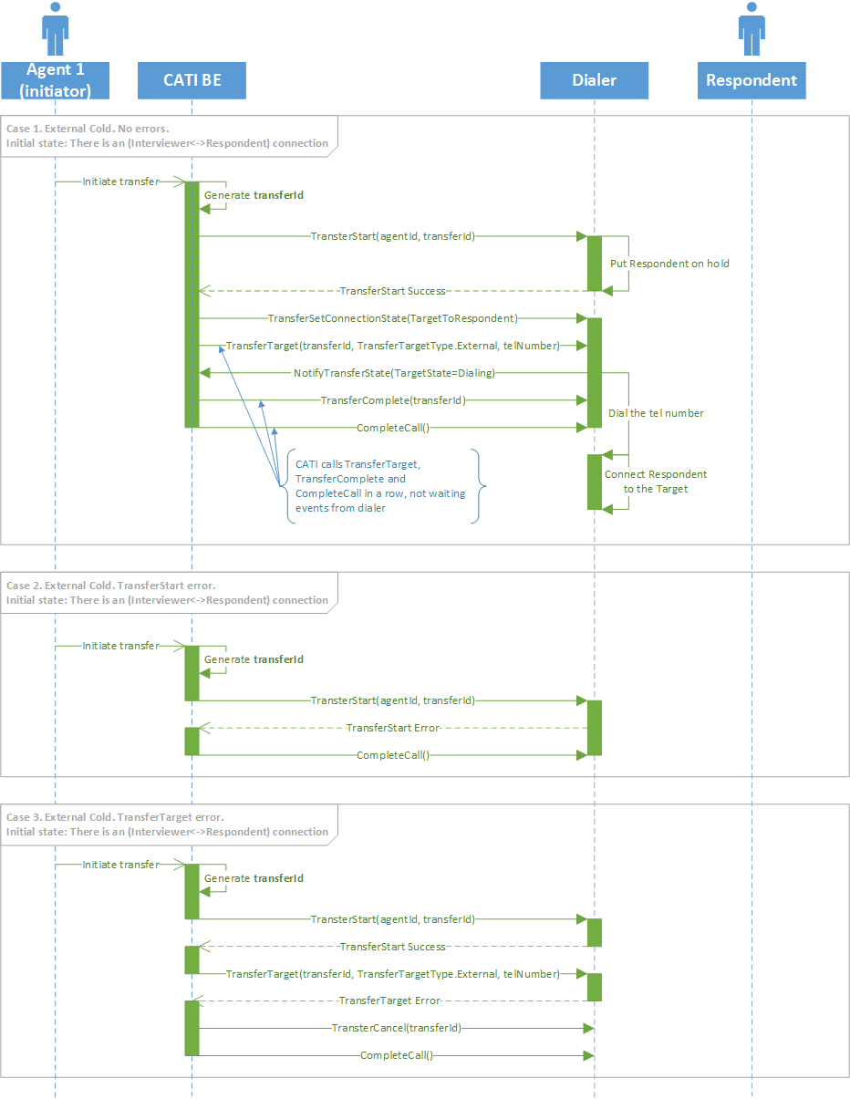

Case 2. External Warm
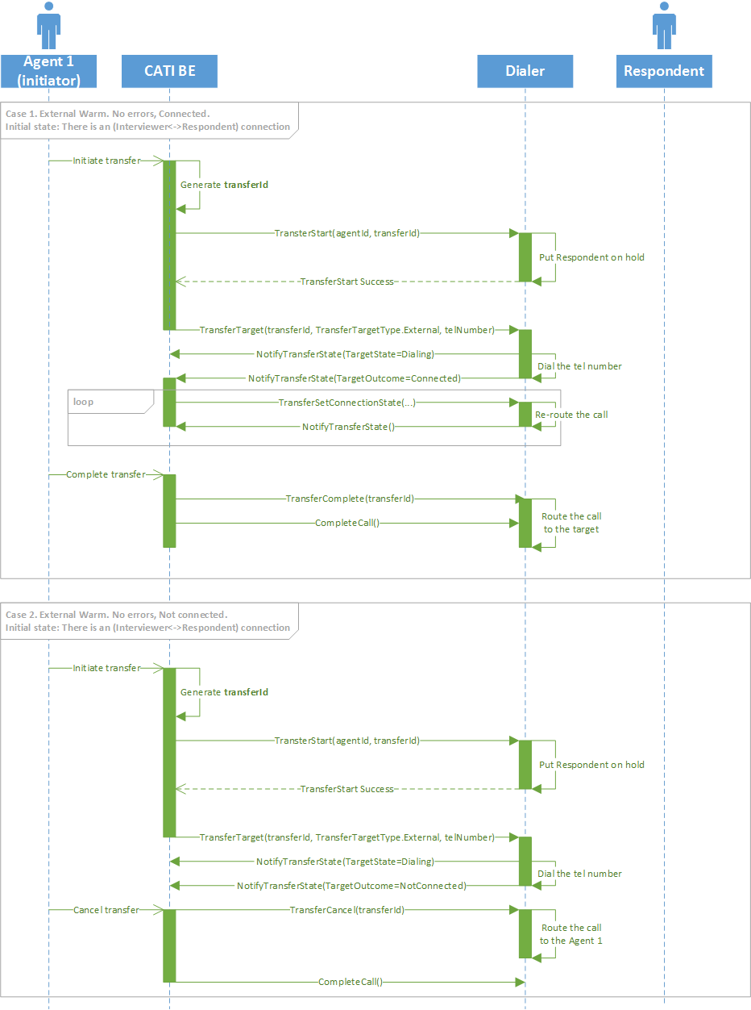

Case 3. Internal Cold Predictive
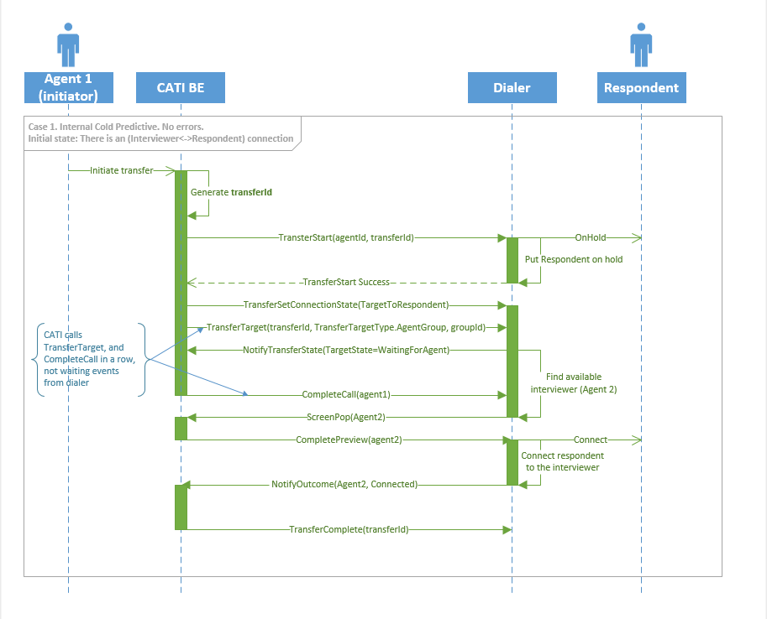

Case 4. Internal Cold Non-Predictive
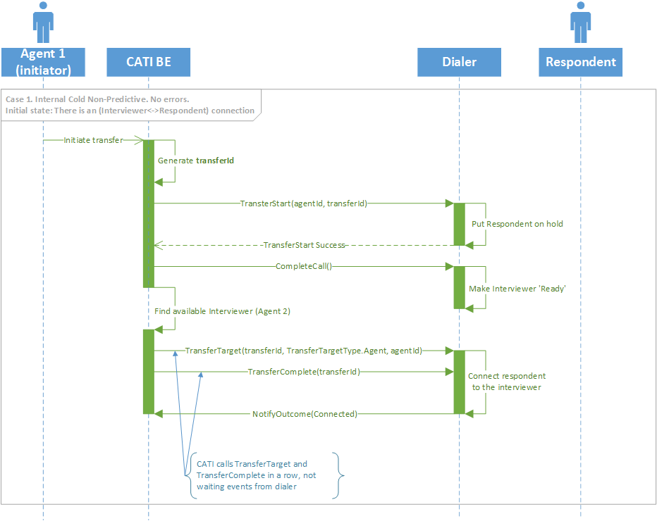

Case 5. Internal Warm Predictive
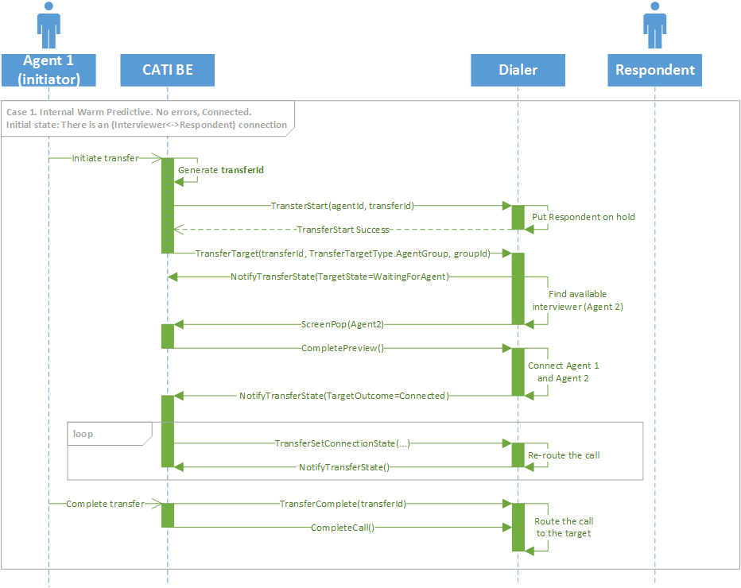
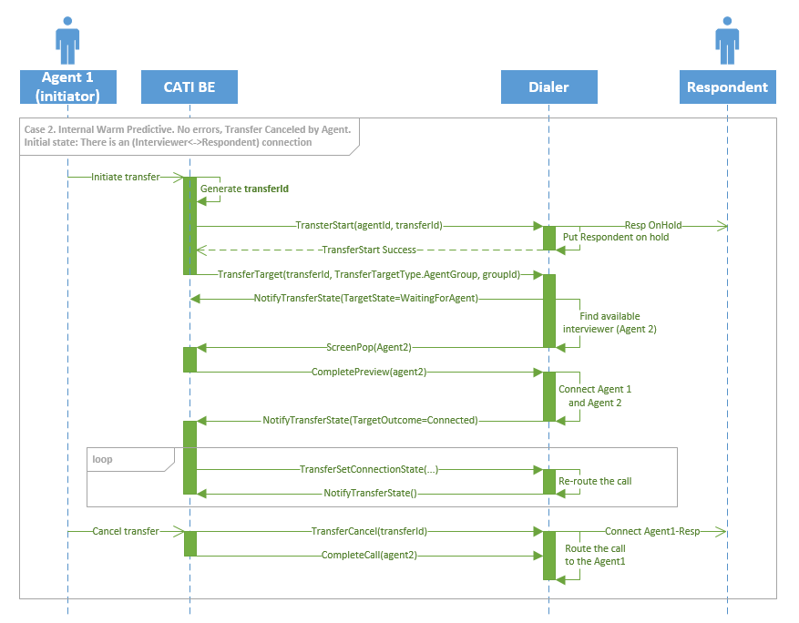

Case 6. Internal Warm Non-Predictive
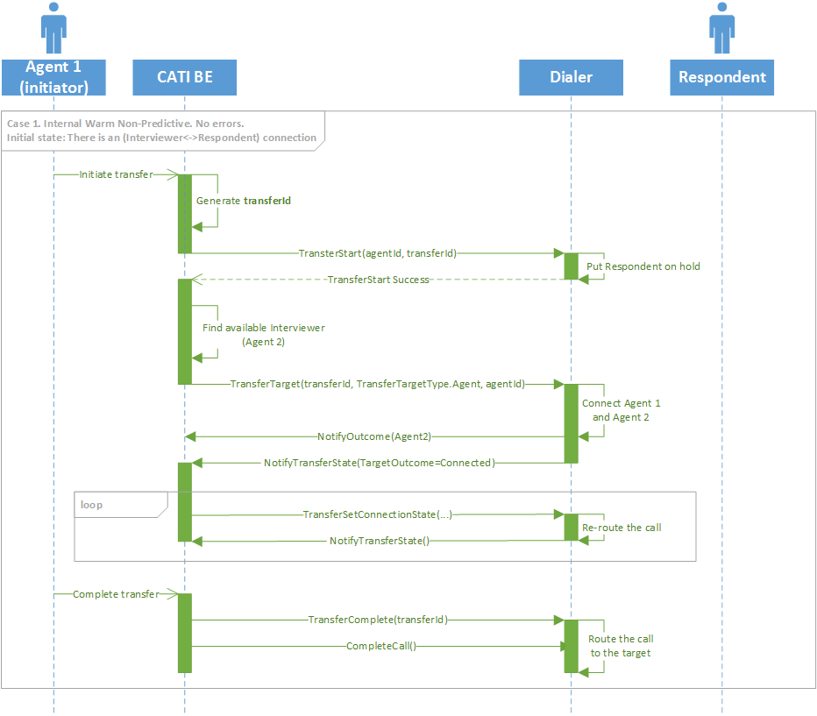
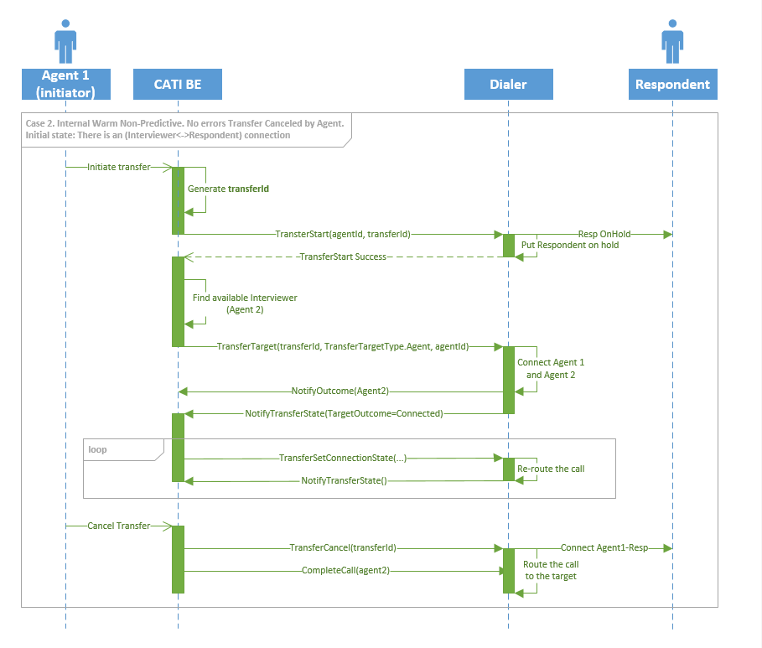

Open Dialer Call Transfers Support API

TransterStart(int companyId, int dialerId, long campaignId, string transferId, int agentId, TransferType transferType)
Creates transfer session, generates transfer ID and puts respondent on hold. Internally this should contain a call set ConnectionState.InitiatorToTarget, although we did not set a target yet. So by default initiator should be connected to target during dialing and when the connection has been established.
TransferType {ExternalCold, ExternalWarm, InternalCold, InternalWarm}.
TransferId is unique (contains a GUID).

TransferSetTarget(int companyId ,int dialerId, long campaignId, string transferId, TargetType targetType, string targetResource, bool borrowAgentsFromAllCampaigns)
This should include the target, specified by type and targetResource, into the transfer session.
The actual behavior will depend on a target type:
- For TargetType.External this should start calling a telephone number specified in targetResource and connect it to the transfer.
- For TargetType.Agent this should connect an agent (with ID specified in targetResource) to the transfer.
- For TargetType.AgentGroup this should find an available agent in the group (group ID specified in targetResource) and connect it to the transfer session.
TargetType { External, Agent, AgentGroup}

TransferSetConnectionState(int companyId, int dialerId, long campaignId, string transferId, ConnectionState state)
Connects 2 out of 3 sides of transfer according to specified parameter. This method can be called at any point during transfer, even if we do not have a connected target.
ConnectionState {InitiatorToRespondent, InitiatorToTarget, TargetToRespondent, Conference}

TransferComplete(int companyId, int dialerId, long campaignId, string transferId)
Connects target and respondent, disconnects initiator from transfer and removes transfer session. Following CompleteCall() calls should not affect respondent after TransferStart().
CompleteCall() may be called before or after the TransferComplete().

TransferCancel(int companyId, int dialerId, long campaignId, string transferId)
Connects initiator and respondent, disconnects target from transfer session, releases transfer session.

NotifyTransterState(int companyId, int dialerId, string transferId, TransferState transferState)
Notifies Confirmit CATI about current transfer session state. This notification should be sent when any change to the transfer state has been made. The transferState object is allocated and maintained by the dialer. It makes sense to allocate it during the TransferStart call and associate with a specific transferId. All fields in a transferState object should have correct values reflecting current state of transfer session. Even if the field value has not been changed – it should have correct value. Some values may be set to NotDefined only if it does not make sense at a certain point of transfer session (for example TargetOutcome can be NotDefined before the target has been set).

TransferState { int InitiatorAgentId,
InitiatorState {NotDefined, Connected, NotConnected},
ConnectionState {NotDefined, InitiatorToRespondent, InitiatorToTarget, TargetToRespondent, Conference},
TargetType {NotDefined, External, Agent, AgentGroup},
TargetResource {telNumber or agentId or groupId},
TargetState {NotDefined, Dialing, Connected, NotConnected, WaitingForAgent}
TargetOutcome {NotDefined, Connected, Busy, NoReply, ...}}

